Final Report

for

Team #29: TTI Tubular Rail

Team members

Aidan Casey

Blake Jones

Imran Khan

Hogan Sullins

Submitted to fulfill

the requirement for a final report in

ISEN 460

Department of Industrial and Systems Engineering

Texas A&M University

4/23/2017

Course Teaching Team:

Dr. Mark Lawley

Mr. James Flores

Mr. Robert King

Mr. Andrew Rihani

Mr. Jose Vazquez

Advisor: Dr. Satish Bukkapatnam

Project Sponsor: Dave Sparks

CONTENTS

1. Executive Summary………………………………………………………………………………….. 3
2. Introduction & Background………………………………………………………………………. 3

3.0 Problem Identification……………………………………………………………………………… 3

3.1 Problem Statement ..……………………………………………………………………… 3

3.2 Scope…………………………………………………………………………………………..... 3

3.3 Constraints/Requirements…………………………………………………………….. 4

3.3.1 Requirements ..………………………………………………………………... 4

3.3.2 Economic Factors ……………………………………………………………. 4

3.3.3 Health & Safety ……………………………………………………………….. 4

3.3.4 Mechanical Constraints …………………………………………………… 4

3.3.5 Social Impact……………………………………………………………….…... 4

3.3.6 Political Constraints……………………………………………………….... 5

3.3.7 Data………………………………………………………………………………….5

* + 1. Route Design Constraints…………………………………………………. 5

4.0 Governing Standards…………………………………………………………………………….......5

5.0 Methodology/Approach……………………………………………………………………...…… .5

5.1.1 Data Preparation…………………………………………………………………...….... 5

5.1.2 Linear Program…………………………………………………………………...……... 6

5.1.3 Simio……………………………………………………………………………………...….. 6

6.0 Project Schedule…………………………………………………………………………………….... 7

7.0 Analysis Outcome and Findings……………………………………………………………….. 7

8.0 Recommendations………………………………………………………………………….……….. 9

8.1 Conclusion………………………………………………………………………….………... 9

8.2 Current State……………………………………………………………………….……….. 9

8.3 Future State……………………………………………………………………….………… 9

9.0 Appendix………………………………………………………………………………………………... 10

9.1 References…………………………………………………………………………………… 13

9.2 Skill and Capabilities Used in this Project…………………………………….... 13

1. EXECUTIVE SUMMARY

Texas A&M Transportation Institute (TTI) has proactively identified a future problem stemming from Texas A&M’s continued student body growth; as the student population expands, the main campus becomes more crowded and greater stress is placed on the transportation infrastructure. In order to combat this issue, TTI has asked our team to devise the optimal route for three methods of transportation: Tubular Rail, dedicated lane bus rapid transit (BRT), and subways. With the Tubular Rail technology in particular, TTI requested that the team evaluate if implementation was feasible in the first place, as the technology has many technical disadvantages (as outlined in section3.3.4) to go along with its many cost saving benefits. Using a combination of linear programming and Simio modeling, our team came to the conclusion that there are several routes for which Tubular Rail is feasible. From a ridership perspective, the subway proved to alleviate the most pressure from the current bus system, but from a cost-benefit perspective the Tubular Rail technology is by far the most cost friendly technology.

1. INTRODUCTION & BACKGROUND

Founded in 1950, the Texas A&M Transportation Institute works develop solutions for challenges for any mode of transportation. With over 200 public and private sponsors, $58 million of annual research expenditure, and a staff made up of more than 400 professional researchers, TTI conducts over 600 projects annually. TTI's research is widely recognized for its powerful impact in saving time and improving safety in transportation.

As Texas A&M continually expands the size of its campus and the size of its student body, TTI has kept a close watch on the transportation needs of the student population. TTI put out a Request for Information (RFI) to companies to propose transportation solutions for the future of Texas A&M. There were some very interesting responses, but the most realistic of these were a subway system, a BRT, and the Tubular Rail.

A subway system is a train system that transports students underground. A BRT is a dedicated lane used for busses to transport students without having to deal with outside traffic. These two systems have been tried and tested in other metropolitan areas. Tubular Rail, however, is a novel system which has not yet been tested in full scale. Tubular Rail consists of a train held up by stanchions. The appeal of Tubular Rail is that it will be more cost friendly and will have less of an impact on the infrastructure of campus.

1. PROBLEM IDENTIFICATION
   1. PROBLEM STATEMENT   
      As Texas A&M continues to expand, the current transportation infrastructure must expand in a similar manner in order to accommodate the school’s growth in a healthy, sustainable way. Our team was tasked with evaluating the feasibility of three different modalities of transportation – subway, dedicated lane BRT, and tubular rail – based on their feasibility of implementation and cost effectiveness.
   2. SCOPE

The nature of this project deals almost exclusively with identifying the optimal route(s) for each of the three modalities, as this project is the first piece in a multi-phase endeavor. Each modality has varying constraints as outlined below, and as such the optimal feasible route for each differs greatly. Tubular Rail in particular is a technology that has yet to be implemented, and while it offers many advantages it also comes with a great deal of constraints. Our team used linear programming and visual basic to evaluate if there were effective routes for Tubular Rail despite its constraints.

* 1. CONSTRAINTS/REQUIREMENTS
     1. REQUIREMENTS

The client asked that the team evaluate the feasibility of a Tubular Rail line on campus while considering both the infrastructural limitations of the technology and the ridership data of each bus stop location on campus. While no further requirements were given to us by TTI, they did request deliverables in the form of a modifiable linear program in visual basic that would find the optimal route for any technology given its associated constraints.

* + 1. ECONOMIC FACTORS

The various modalities of mass transit each differ significantly in their projected cost of implementation. Robert Pulliam, President of Tubular Rail, projects that the cost of implementation would be in the $20-$30M per mile range for the technology. Austin Rail Now reports that the average cost of subways in the United States reaches upwards of $585M per mile, making it easily the most expensive method of transportation that the team evaluated. The dedicated lane bus rapid transit system has the largest degree of uncertainty in regard to cost, as Reconnecting America reports that these systems cost $4-$40M per mile. It should be duly noted, though, that the scope and nature of this project focused on the routes themselves and did not revolve heavily around cost-benefit analysis. As such there are a myriad of other cost factors that must be taken into consideration by future teams such as energy efficiency and maintenance.

* + 1. HEALTH AND SAFETY

One of the largest advantages of Tubular Rail is its minimal carbon footprint relative to other methods of mass transit. Dartmouth University reports that Tubular Rail’s footprint would be roughly 800 BTUs/passenger/mile, as compared to 4500 BTUs/passenger/mile for buses and 3500 BTUs/passenger/mile for light rail systems similar to a dedicated lane BRT system. Both a Tubular Rail system and subway system would also provide the added benefit of improving pedestrian and bicyclist safety; both technologies are either well above or below ground level and as a result would not interfere with pedestrian and cyclist traffic, thus greatly reducing the probability of accidents

* + 1. MECHANICAL CONSTRAINTS

Perhaps the largest drawbacks to the Tubular Rail technology are its technical limitations. According to Dr. Robert Pulliam, the turning radius for the rail is 5000 feet, and it takes 100 feet for the rail to raise 1 degree in elevation. This greatly inhibits the number of feasible routes for the technology, as Texas A&M’s main campus is dense and compact, and there are very few viable places where straight line routes can be created without affecting the current infrastructure. On the other hand, although it is the most expensive modality evaluated, a subway system would not have to account for the numerous buildings on campus and has very few limiting factors as far as route design is concerned. The dedicated lane BRT system would likely overlap or replace the current bus system, and as such its mechanical constraints are very similar to those already accounted for by the bus system.

* + 1. SOCIAL IMPACT

The social impact of each of the three modalities would be the creation of a less crowded and more efficient campus. Students would be able to travel around campus more easily with shorter wait and travel times. In addition, Tubular Rail offers the advantage of allowing Texas A&M to pioneer and pilot a novel and potentially transformation technology. Implementing Tubular Rail would undoubtedly lead to increased PR and marketing opportunities for A&M, and would allow the school to have a hand in shaping the technology as it moves forward.

* + 1. POLITICAL CONSTRAINTS

With perhaps the exception of the dedicated lane BRT, each of these systems would require quite a few government permits and sign-offs before they could be realistically considered. Depending on which technology were selected, there may be a necessity for easements, especially as the systems expand over the years. There were no political constraints to be considered during the creation of our linear program, but moving forward governmental entity requirements will need to be considered.

* + 1. DATA

The largest constraint that our team faced was the data readily available for analysis. The team received ridership data for each bus stop for the month of October. This data included the number of people who got on and off each bus during each stop throughout the day. The largest issue that this data poses is that there is no way of tracking individual passengers throughout their journey. For instance, if 5 people get on the bus at the MSC, do all 5 people get off at the same location or do they each stop at different locations? It would be extremely useful to discern where passengers start and begin when designing the routes, but due to time and resource constraints the team was unable to do this ourselves. As such, the routes proposed do not take into account where passengers are likely to get off, it only takes into account a weighted ratio of how busy each bus stop is and assumes that the busier bus stops should have heavier weights.

* + 1. ROUTE DESIGN CONSTRAINTS

The route design itself had several constraints that needed to be input into the linear program. The first constraint was that there needed to be at least half a mile between two consecutive stops. If stops are too close together it would negate the benefits of technologies such as Tubular Rail or a subway, as the time saved by these technologies would be minimal. Next, the total route distance was constrained to being between 2.25 and 2.75 miles. TTI mentioned wanting the pilot route for any new technology to be roughly 2.5 miles, and our range allows us to not abruptly cut off the route at an awkward location.

1. GOVERNING STANDARDS   
   In 2015 the United States Environmental Protection Agency enacted Tier 4 emissions regulations for locomotives that would likely apply to modalities such as Tubular Rail. Although it has been mentioned that Tubular Rail is an emission friendly technology, it is currently only in the concept stage of development and as such the true emissions rate must be evaluated and must be below the governing limit. If a permanent transportation system were to be implemented that eventually extended off campus, then procedures to obtain easements would also need to be reviewed by the team in order to receive the right to place the stanchions in the optimal locations.
2. METHODOLOGY/APPROACH
   * 1. DATA PREPARATION

The linear program called for two calculations before it could be created. First, the team needed to calculate the distance between every possible bus stop combination on campus to the thousandth of a mile. An online program that allows you to use precise latitude and longitude coordinates was used to calculate the distance. Once the distance for each stop combination was calculated, the inverse ridership metric for each bus stop was found. The inverse ridership metric is calculated as 100% - (the percentage of passengers who get on at a given bus stop in a month relative to the total number of passengers at all on campus stops in that month). The rationale behind subtracting the ridership percentage from 100% is that the linear program has a minimization objective function (explained below), yet the team wanted to maximize the number of riders that are reach. Therefore, the inverse ridership metric essentially flips the ridership ratio so that, when the metric is put through the linear program in the objective function, it maximizes the number of passengers reached.

* + 1. LINEAR PROGRAM

The objective function in the linear program minimized the product of the distance between two potential stops and the inverse ridership metric. The program begins with the assumption that the first stop is the MSC. From there it evaluates the objective function for each possible stop to determine where the route will go from the MSC. The program takes into account the route design constraints as documented in section 3.3.8. After evaluating the optimal route beginning at the MSC, the program picks a new bus stop as the beginning of the route and goes through the same steps. This process is repeated for each on campus bus stop. While, once the transportation system expands, there could be multiple lines or branches, the team did not incorporate that into our linear program, as it would not make sense to open multiple lines during a pilot or trial program. Our routes did not contain branches or intersections in order to realistically simulate a simple, plausible pilot route.

* + 1. SIMIO

Simio, a scheduling simulation software, was used to measure the projected ridership of the ideal route for each modality. First the team modeled the on campus bus system as it currently is. The team received time series data of passenger arrivals from TTI and used this to model the passenger arrival rates at each station. The team also modeled what would happen if more buses were simply added to the system. Once the current system was modeled and the system with more buses, the team was able to add the proposed routes on top of the system in order to get an estimate of projected ridership and cost per passenger mile for each modality.

5.1.3.1 SIMIO INSTRUCTIONS

Editing Vehicles:

To change capacities or speeds of the busses or any vehicle, click on the vehicle you want to change and its properties will appear in an editable table on the right hand side of the Simio display. To change multiple properties at once right click any vehicle and select the “open properties spreadsheet view for all objects of this type. A list of the vehicles will appear at the bottom of the Simio display and their properties can be edited there.

Editing arrivals: (for possible analysis of future projected ridership)

Rate tables can be found in the data tab when viewing the model. After selecting the “rate tables” option on the left you can edit arrivals for any hour of the day for all of the stops.

Running the simulation:

In order to run the simulation click on the run tab within facility tools at the top of the Simio display. At the top left-hand side of the page there is a green run button that starts the simulation. To skip to the end of the simulation click on the “fast-forward” button in the same area and let the simulation finish its run.

Checking results:

After successfully running the simulation you can view results in the “Results” tab at the top of the model. You can sort by which data types you want to view. To run several replications on the simulation to get more accurate numbers and check repeatability of everything, click on the “project home” button at the very top of the Simio display. Click on the “New experiment” button and choose how many replications you want to run and set the parameters of the experiment. Allow ample time for the experiment to finish and then results can be viewed there.

1. PROJECT SCHEDULE

2/8/17 – TTI – Tubular Rail Team 29 was formed

2/8/17 – Team 29 met for the first time to prepare introductory presentation

2/13/17 – Team 29 group meeting to prepare for conference calls

2/15/17 – First conference call with Dave from TTI

2/16/17 – Conference call with both TTI and Robert Pulliam from Tubular Rail

2/19/17 – Team 29 group meeting to develop proposals for potential projects

2/22/17 – Team 29 approached Dr. Bukkapatnam to ask if he would be the team’s advisor

2/24/17 – Conference call with TTI

2/26/17 – Team 29 takes group photo

2/27/17 – Team 29 group meeting

2/27/17 – In person meeting with TTI and Tubular Rail in Research Park

2/28/17 – Team 29 signs up for the engineering showcase

3/6/17 – Team 29 group meeting

3/6/17 – Met with Dr. Bukkapatnam in person to discuss project

3/20/17 – Team 29 group meeting and post-spring break recap

3/21/17 – Received on campus bus ridership data for month of October 2017

3/22/17 – Met with Dr. Bukkapatnam in person to discuss updates on project direction

3/23/17 – Team 29 group meeting to work on algorithm

3/29/17 – Met with Dr. Bukkapatnam to discuss project

4/2/17 – Team 29 group meeting to work on algorithm

4/6/17 – Team 29 group meeting to work on Tableau Dashboard presentation for TTI

4/7/17 – Update conference call with TTI and Tubular Rail

4/10/17 – Team 29 group meeting

4/11/17 – In person progress meeting with TTI

4/16/17 – Team 29 group meeting to work on algorithm and Simio

4/23/17 – Team 29 group meeting to finish algorithm and Simio

4/27/17 – Team 29 group meeting to prepare for final parts of project showcase

4/28/17 – Texas A&M Engineering Project Showcase

5/3/17 – Department Showcase

1. ANALYSIS OUTCOME AND FINDINGS

First our team constructed an on campus heat map along with a corresponding ridership table. The heat map provided a visual representation of the areas of campus that the team needed to focus on, while the table allowed the team to calculate the inverse ridership metric.

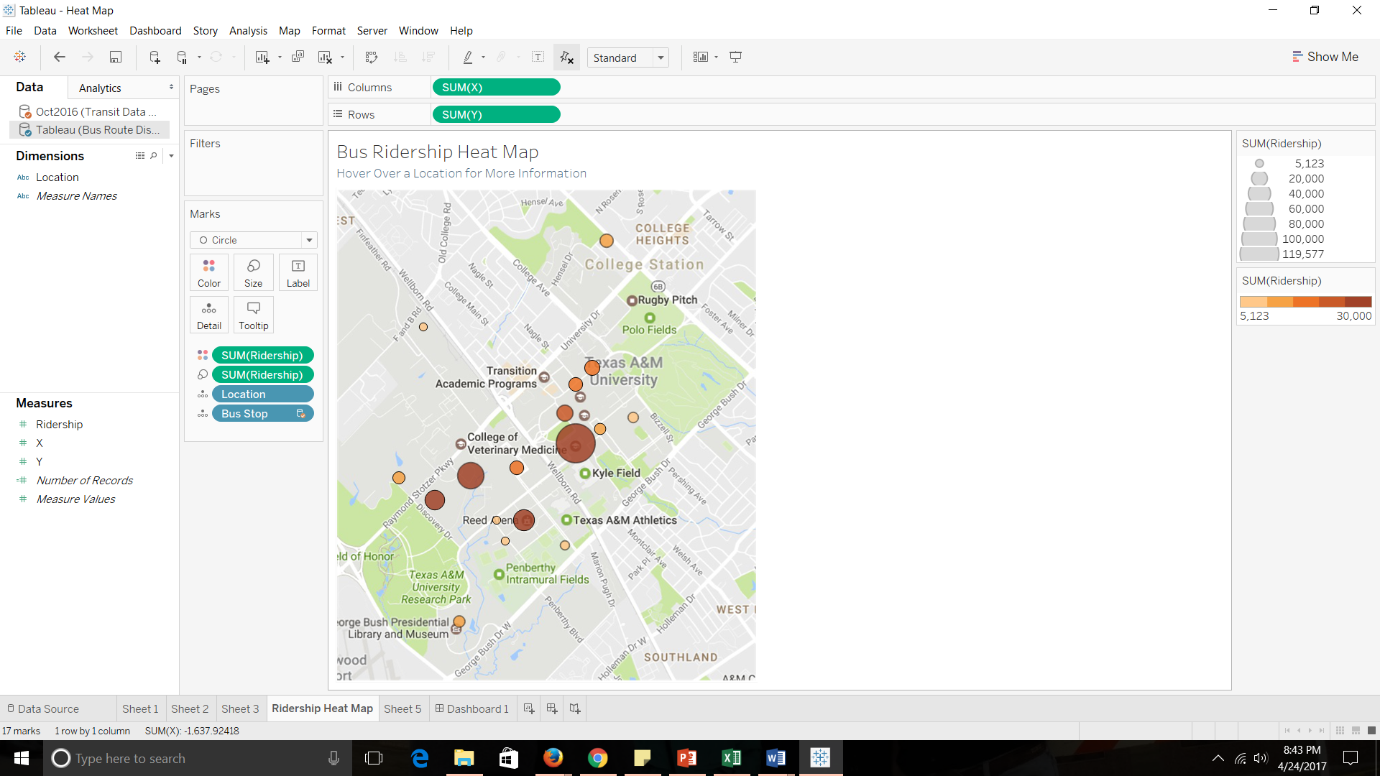

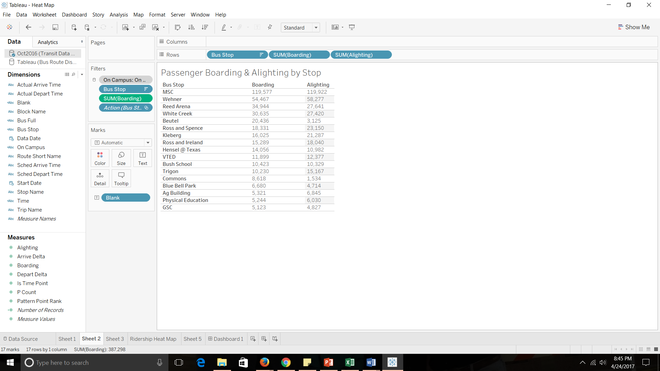

Next, the team created the tables needed for the linear program to successfully execute. These tables included geographic coordinates, precise distances between bus stops, and a binary table indicating whether a straight line path was possible between two locations or not.

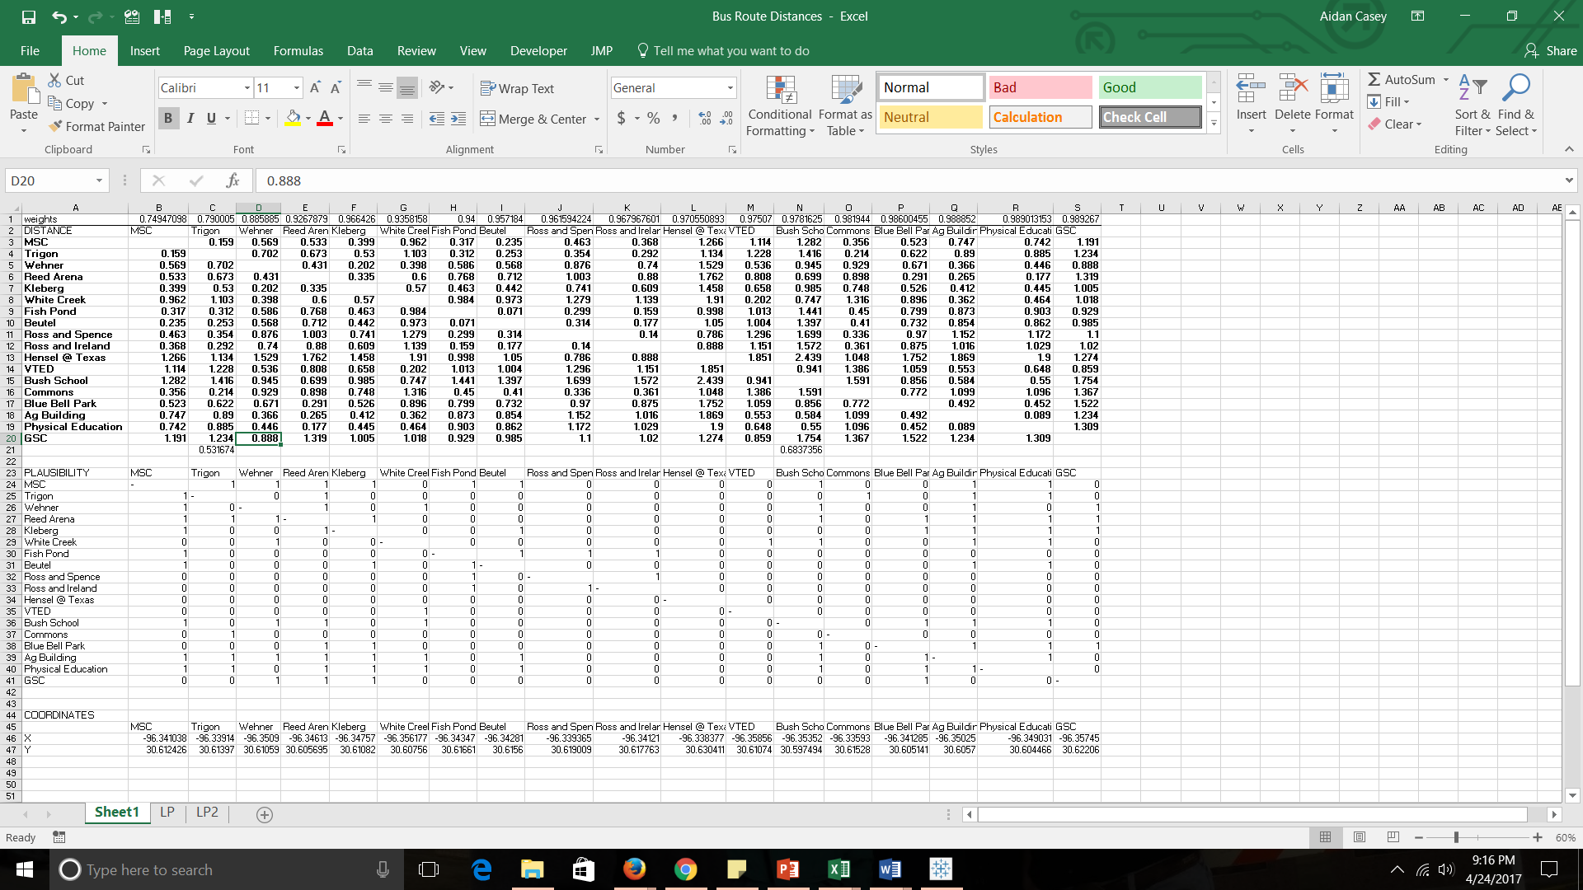

Once the linear program was run, an output of two optimal routes was obtained: one for a subway or dedicated lane BRT system, and another for Tubular Rail. While the subway and dedicated lane BRT system have the same route due to the similar mechanical capabilities of each system, it is important to note that their ridership and cost per passenger mile vary due to differing speeds of the modalities. The optimal subway/BRT route was a loop that travels from Ross & Spence to Ross & Ireland to Wehner to PEAP/Reed Arena to Blue Bell Park to the MSC and back to Ross & Spence. The optimal Tubular Rail route consisted of two separate lines – one from Wehner to the MSC, and another from the MSC to Reed Arena to George Bush Library.

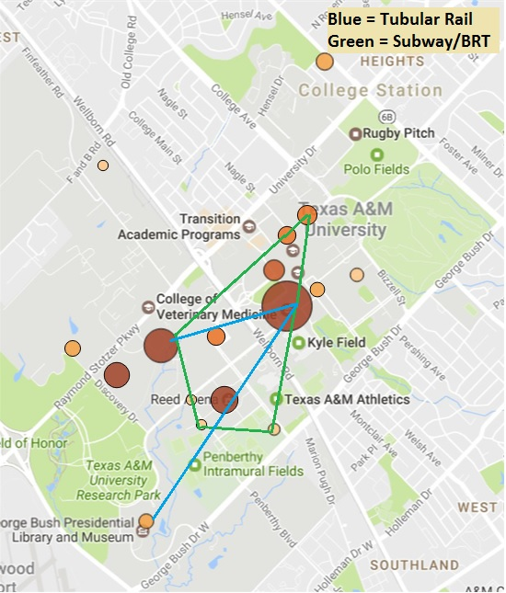

The Simio simulation demonstrated a 45% reduction in traffic and 46000 riders per month for the subway route. Interestingly enough, the program found that the optimal route Tubular Rail route reduced traffic by 22%, but had double the ridership of the subway system (projected at 92000 riders per month). The projected full cost of implementation for Tubular Rail would be $36M-$54M, which would come in at $0.63B-$2.56B cheaper than a subway system, and $105M-$197M cheaper than a dedicated lane BRT system.

The team also evaluated the possibility of simply adding more diesel buses to the current A&M bus system. Each bus costs roughly $300k-$600k, so adding one bus to each on campus line would cost roughly $800k. When this was incorporated into the Simio model, the average wait time reduction was only 4-5%. The team determined that simply adding buses would not be a viable option based on this analysis. While it may be more cost effective to take the approach of adding buses, it isn’t realistic because the on-campus congestion and traffic factor would rise significantly if several dozen buses were added to the system. Adding a large number of buses would also only serve as a temporary band-aid to the transportation system and would not be an effective solution once campus expands and the student body grows.

1. RECOMMENDATIONS
   1. CONCLUSION

It is important to note that the primary question at hand was to address whether or not there was a feasible on campus route for Tubular Rail, taking into account its physical limitations, that would significantly alleviate stress from the current A&M transportation system. In that regard, the team found that the Tubular Rail route provided by the algorithm would significantly improve the current transportation system, with an average of 22% reduction in passenger wait time and projected monthly ridership of 92,000 given the current ridership of A&M’s bus system. Based on the team’s Simio model, the subway system did reduce the average wait time by more than Tubular Rail (an average wait time reduction of 45%), its projected ridership was roughly half that of Tubular Rail’s.

* 1. CURRENT STATE

When viewing Texas A&M’s transportation problem strictly through the lens of the team’s project scope, Tubular Rail looks to be a promising option. The MSC, Wehner, and Reed Arena are the three busiest bus stops on campus, and Tubular Rail would be able to reach all three. The route also has the added benefit of heading towards the direction that campus is currently expanding. The cost per passenger for Tubular Rail would be significantly cheaper than that of a subway and a little bit cheaper than that of a dedicated lane BRT.

* 1. FUTURE STATE

Despite the promising prospect of Tubular Rail, the concept technology still faces many obstacles in future analysis. While this team has shown that there is a viable on campus route for the technology that could potentially save a great deal of money, many other factors will need to be considered before pursuing the Tubular Rail technology. For instance, as campus continues to grow, a dedicated lane BRT system offers much greater flexibility and scalability in regard to route design. Tubular Rail has limited ability to adapt, and as more and more buildings are created on campus the technology’s potential routes become fewer and fewer. As such, the team recommends two more steps in future analysis.

The first would be a more thorough and in depth cost analysis. The cost figures obtained by this team included only construction costs, but many more costs such as easements, government permits, maintenance, etc. would need to be incorporated, and then a concrete cost per passenger mile metric should be obtained.

The next step, and perhaps most challenging, would involve evaluating all three modalities in a simulated environment based on Texas A&M’s projected growth (both in terms of student body growth and campus infrastructure growth). While Tubular Rail is a viable option given the current size and layout of campus, this could quite easily changed within the next decade or two, and as such the technology’s feasibility should be evaluated under more long term conditions and not just based on the current state of Texas A&M.

1. APPENDIX

**VBA Optimization Code**

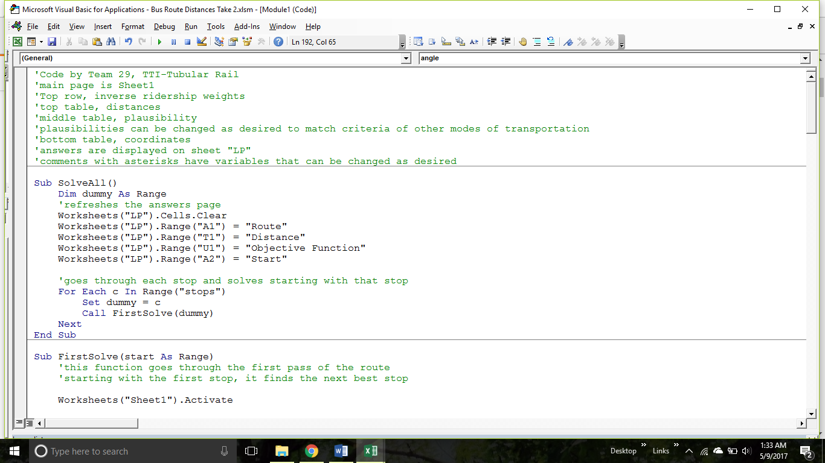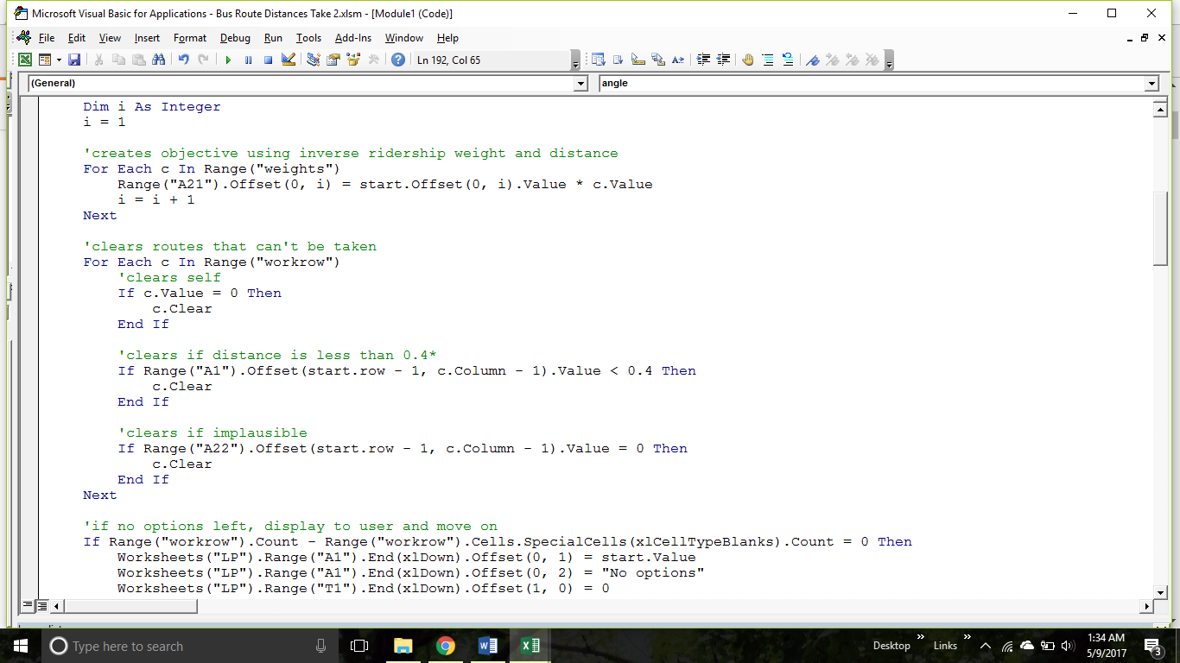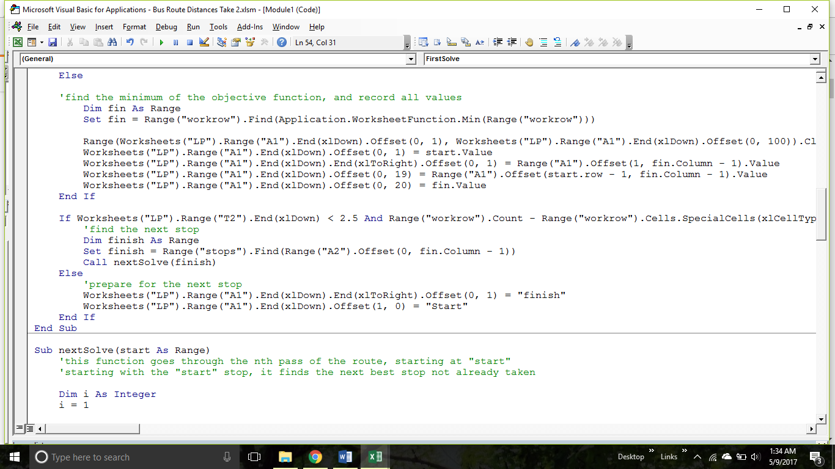

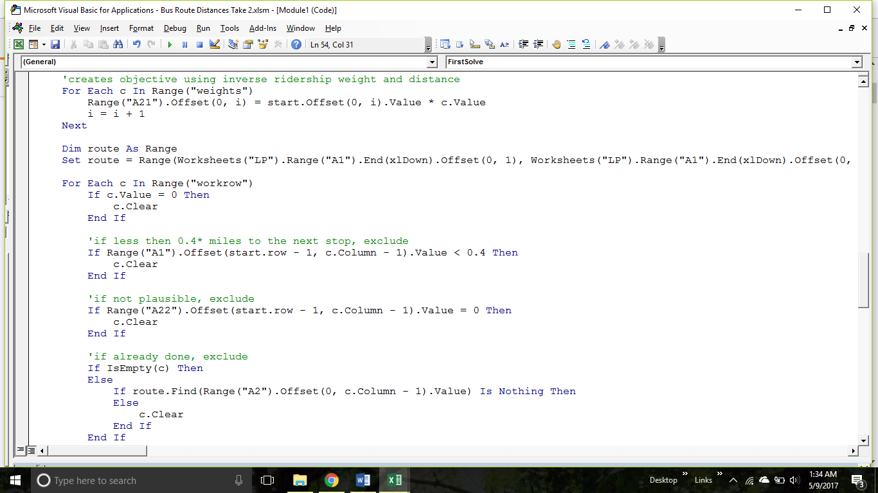

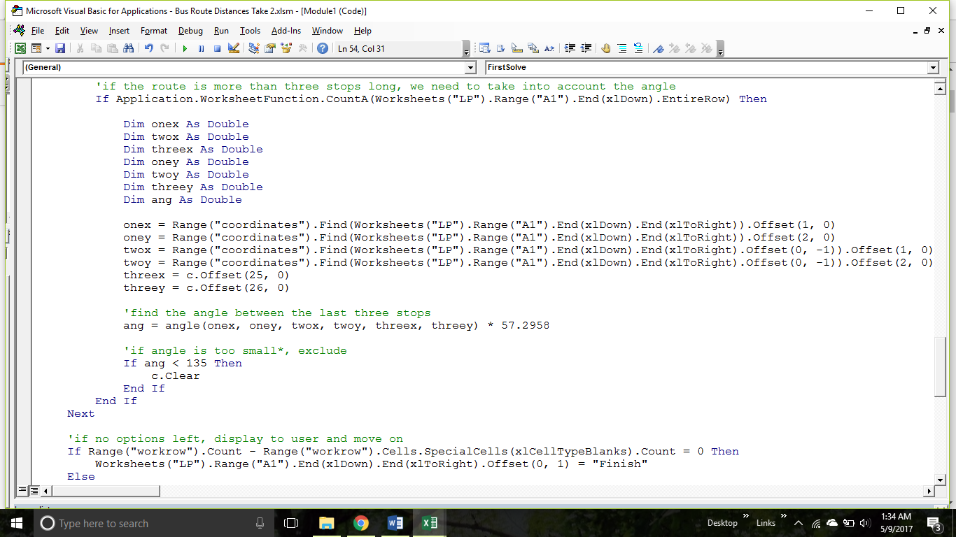

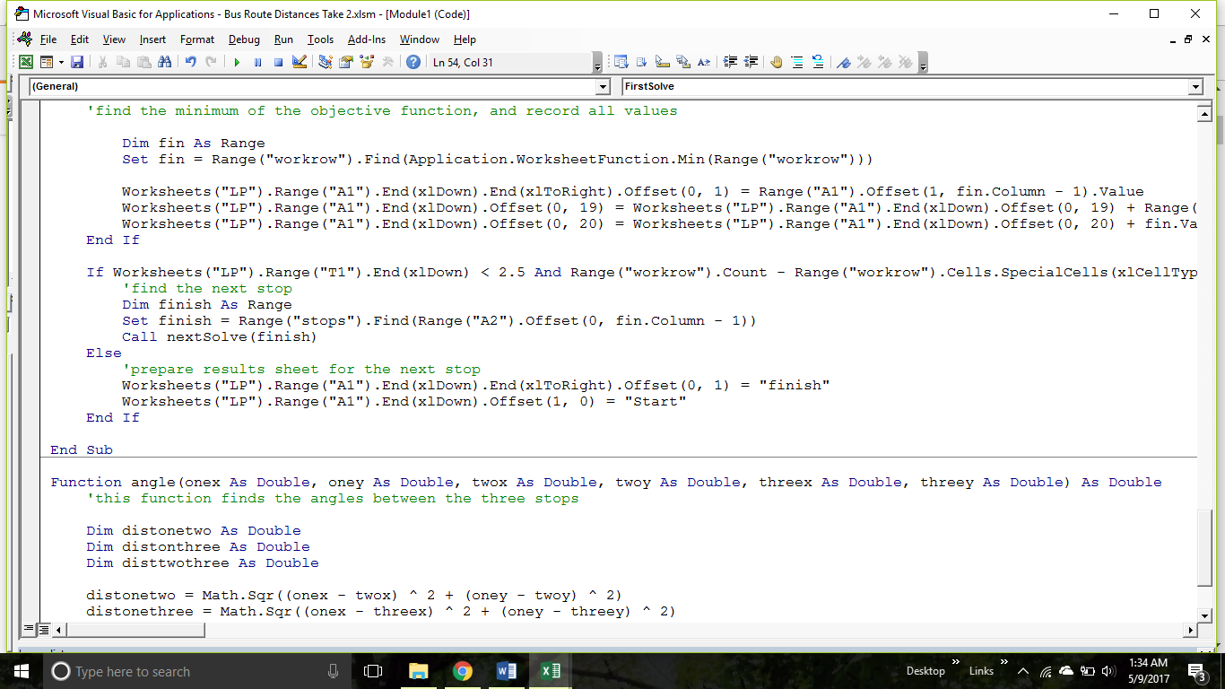

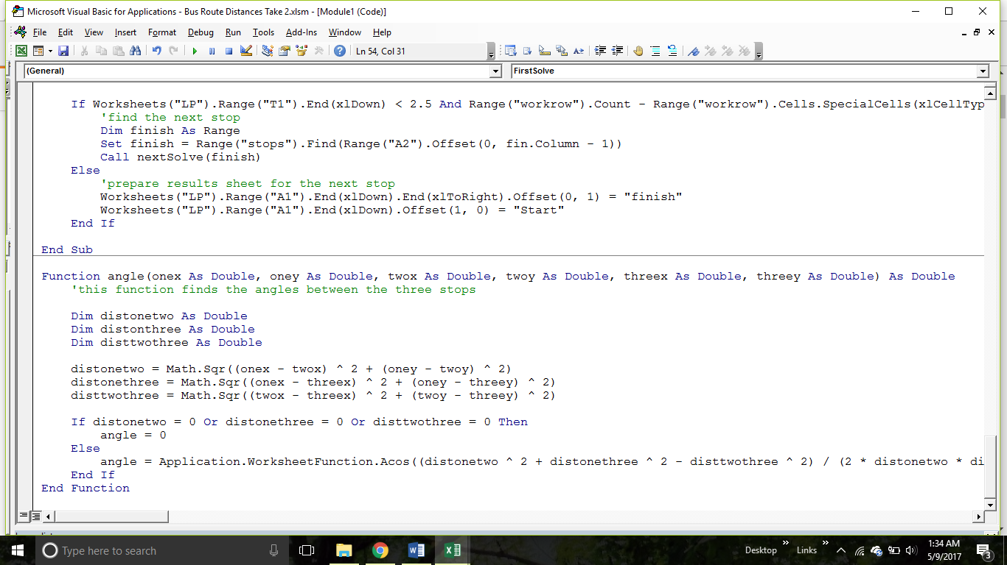

* 1. REFERENCES

TransitBy Matt Johnson (Editorial Board) March 16, 201020. "Average schedule speed: How does Metro compare?" Greater Greater Washington. N.p., n.d. Web. 09 March 2017.

MacKechnie, Christopher. "How Much Does it Cost to Purchase and Operate a Bus?" ThoughtCo. N.p., n.d. Web. 08 Feb 2017.

http://www.tubularrail.com/background.htm

https://tti.tamu.edu/about/

* 1. SKILLS AND CAPABILITIES USED IN THIS PROJECT

These are the skills and capabilities utilized by team members to complete this project:

* Coding in VBA
* Coding in Simio
* Manipulating data in Excel
* Manipulating data in Tableau
* Optimization methods
* Linear programming skills
* Presentation skills
* Interpersonal skills
* Time management
* Group delegation
* Design skills
* Communication
* Writing skills